SERAF  Category of risk | Description | Associated safeguarding actions
Category 1  (Not at risk)  (Score of 0-5) | A child or young person who may be ‘in need’ but who is not currently at risk of being groomed for sexual exploitation | Educate to stay safe. Review risk following any significant change in circumstances
Category 2  (Mild risk)  (Score of 6-10) | A vulnerable child or young person who may be at risk of being groomed for sexual exploitation | Work on risk awareness and staying safe should be undertaken with this child/young person  Review risk following any significant change in circumstances
Category 3  (Moderate risk)  (Score of 11-15) | A child or young person who may be targeted for opportunistic abuse through exchange of sex for drugs, accommodation (overnight stays) and goods etc | Convene multi-agency meeting under local protocol for sexually exploited children and young people to ensure effective exchange of information with multi-agency colleagues and agree protection plan. At least one review meeting to be convened  Work should be undertaken with this child/young person around risk reduction and keeping safe
Category 4  (Significant risk)  (Score of 16+) | Indication that a child or young person is at significant risk of or is already being sexually exploited. Sexual exploitation is likely to be habitual, often self-denied and coercion/control is implicit | Convene multi-agency meeting under local protocols for sexually exploited children and young people to ensure effective exchange of information with multi-agency colleagues and agree protection plan, including regular review meetings  Protection plan should include long-term intensive direct work with the child or young person
Moderate or | Young person aged  18 years or above | Where a young person is aged 18 years or over the associated action in relation to Moderate and Significant risk: sexual exploitation should be addressed as an issue in relation to this young person through the Pathway or other work plan; liaison between children’s services and Police Public Protection Unit to address the young person’s protection
Significant risk | Young person aged  18 years or above
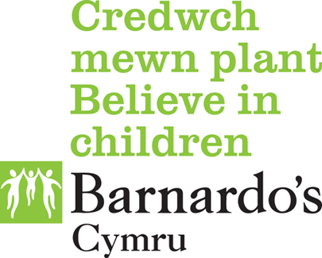

SERAF Categories of Risk Framework

